Biography
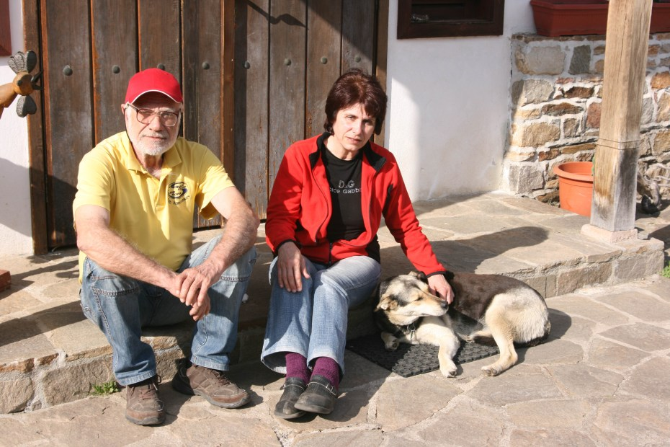
We are Svetlana and Hristo. For many years we lived and worked in Latin America. When a person lives abroad for a long time, the longing for Bulgaria gets really strong. During one of our vacations back in Bulgaria we stumbled upon the Kosovo village and it captivated us immediately – with its peace and quiet, its cobblestone streets, the typical Rhodopean houses, spread on the hills.
When we decided to return to Bulgaria for good and to change our way of life, we were certain that Kosovo village would be the place we wanted to settle in. And so, with the active participation of friends and family, we gave birth to the ”Kosovo Houses”, built with hard work, love and a desire to preserve the true Bulgarian spirit. It is of immense value, as it is a part of us.
We welcome our guests with pleasure and want to show them this feeling, the authenticity of Rhodopean atmosphere and the beauty of Bulgarian nature, which we long for and strive to preserve. Many of our guests have become our friends and keep coming back, as they have felt the magnetic pull of the Rhodope Mountains.
The village of Kosovo is situated in the central area of the beautiful Rhodope Mountains in Southern Bulgaria. It is one of the few villages in Bulgaria, which have conserved their traditional spirit. It is a typical example of the vernacular Rhodopean Renaissance architecture, organically linked to nature. We have restored some of the centuries-old houses in the village, using traditional construction techniques and natural building materials. The houses now combine the authentic architecture with modern comfort.
The Kosovo Houses Complex consists of 3 authentic houses fully renovated and modernized to meet the requirements of the modern traveler. The Hadjiyska house is the most upgraded house, with many authentic elements conserved and restored, such as the old fireplace, the window seat, the wooden ceilings and more; the old barn has been converted into a tavern and there is a real 'cheverme' (to roast meat on a spit). The Gavatovska house is one of the most attractive houses in the village built on several levels with a mehana in the ground floor. The Elinovska House, a former monastery school, is situated on the very top of a hill and offers amazing panoramic views of the area from its large terrace. The 3 houses and 2 of the barns feature rooms and apartments equipped with modern amenities and private facilities.

