Personal Background
Erdem Genç, who is in charge of the most entertaining company of Turkish business World, M3 Works, is engaged in literature, music, and photography as well as his memberships with business world and civil society organisations.
Genç is a graduate of Yıldız Technical University Department of Mechanical Engineering, Anadolu University Department of Public Relations, and Anadolu University Department of Business Administration. Presently, he is attending Istanbul University Department of Justice. Holding an MBA (Entrepreneurship Master’s Degree-with full scholarship) Degree from Özyeğin University, Genç is presently engaged in doctoral studies at Aston University.
Genç has four books titled “Becoming a Boss at the Age of 20”, “Debut”, “Cuban Rhythm,” and “Becoming an Entrepreneur at the Age of 10”. Genç, who served as the editor of Metal Monster magazines from 1999 to 2004, has also written for the magazinesKöprüaltı, Şebek, Dream, and Fortune. He has recordings as lead vocal with Soul Shred and Karma dated 2003 and 2009 respectively and has been playing percussions with playing percussions with Varillazand Ritmboxsince 2006. Genç is also a TOSFED licensed racing driver competing in Intercity Silver Cup, taking place at the Istanbul Park.
Erdem Genç is the President of Young Ceo Club as well as a member of JCI Bahçeşehir Board of Directors, Harley Davidson Owners Group (H.O.G), TOBB Young Entrepreneurs Council, TEGEP, and YTÜMed.
Erdem Genç, who has given seminars on “Entrepreneurship” and “Team Work” and organized events in more than five hundred companies, universities, high schools, and civil society organisations, holds awards from various institutions such as Bosphorus University, Startup Weekend, JCI, Lions, Peryön, and Eduplus.
Genç received the Best Event Supplier award on behalf M3 Works in the World Tourism Forum in 2015, 2016, and 2017, for three years in a row.
In 2015, Genç was awarded the title of Turkey’s Most Successful Young Personin the field of Business World and Entrepreneurship in the TOYP (Ten Outstanding Young Persons) event, which was organized by the International Association of Young Entrepreneurs and Leaders (JCI), which has branches in more than 100 countries.
Last year, Genç was honoured with the award of the Young Entrepreneur of the Year at the Youth Summit of Turkey and this year with the award of the Entrepreneur of the Year by Kültür University.
His debut album “Motivasyon” (Motivation) came out in 2019.
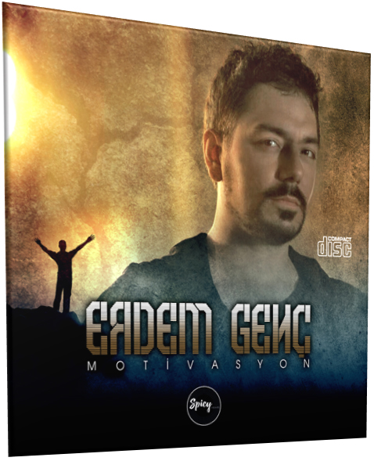

Becoming a Boss at the Age of 20 – Preface
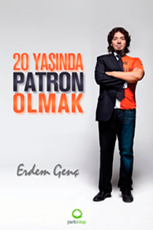
PREFACE
I know quite well how the unbearable lightness of being an entrepreneur at the age of 20 seduces young people with an entrepreneurial spirit. My dear friend Erdem Genç, who became an entrepreneur at a young age, is also one of those who have this spirit.
For winners, there are no excuses in life. For losers, however, there are plenty of them.
When we consider this proposition in terms of the business world, it is a major and valid excuse for a 20-year-old not taking a step to start his/her own business. But what about those young entrepreneurs who do not see this as an excuse and start their own business?
The ecosystems one grows up in is of great importance for becoming an entrepreneur. Entrepreneurship is one of the common characteristics of those who have not lost their ability of free thought, who question life and have high self-confidence.
One day, while a friend of mine from the Young Ceo Club and I were waiting for our coffee orders to be served at a coffee shop, I realized that my friend was touching the coffee machine, trying to explore it. And then I said, “you had a naughty, unruly, quite a curious childhood.” Surprised, he asked “That’s right but how did you understand that?”, to which I replied, “You are so lucky to have a mother who did not blunt your curiosity, self-confidence and questioning but nurture them instead.”
The most important source of capital for an entrepreneur is their parents. Stop, don’t be so quick to get mad… What I’m trying to mean is that the real capital for an entrepreneur is a supportive and loving family nurturing his/her spiritual motivation. The same can be seen in the case of Erdem. How many parents would trust a 10-year-old child with a grocery shop and leave? They trusted Erdem with one. And the result is in the book…
One can make long list of factors that can be considered to be contributing to the insufficient development of an entrepreneurial ecosystem in Turkey; however, it seems like the parents have a major share. I have seen many parents who said “Son, get an insured job. There is also a marriage etc. awaiting you. Don’t get yourself into trouble for no reason” to their children who wanted to start their own business. Parents may not be able to support their children financially but if they fail to provide emotional support, owning a business will unavoidably reach an unattainable level in one’s mind. Are there not any young entrepreneurs who succeed despite this? Of there, there are. Those are the real entrepreneurs who have excluded the word “excuse” from their wordbook!
Before you start reading the book, are you also ready to exclude the word “excuse” from your wordbook to become an entrepreneur?
Ömer NART
President
Young CEO Club
Becoming a Boss at the Age of 20 – Back Cover
“Erdem, who is only 25 years old and a partner of 3 companies, is setting an example for the young generation with his entrepreneurship.”
-Book of Succesful Young People-
“It is time to join and have fun instead of being a mere spectator!”
-Hürriyet Daily News-
“ErdemGenç is a new generation entrepreneur who has cracked the secret of acquiring a fortune while having fun and succeeded to convert his hobbies into money.”
-Daily Taraf-
“ErdemGenç said that they had made music with many other instruments before, but it was more fun to make music with a tractor. Genç stated that they had wrapped cotton around some of the broomsticks they used in order to avoid damaging the tractor which is approximately worth 400 thousand Turkish Liras.”
-Daily Hürriyet-
“ErdemGenç is providing guidance to those who want to develop themselves, avoid missing activities, and capture the campus agenda over a website which he is a founding partner of.”
-Daily Türkiye-
“ErdemGenç is a young person who has taken interest in some branches of art such as literature and music since his childhood, engaged in various activities in these branches and contributed to many magazines.”
-Daily Evrensel-

Becoming an Entrepreneur at the Age of 10 – Back Cover
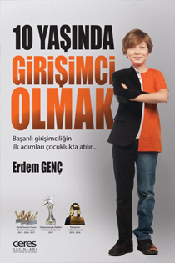
As someone who has admiringly witnessed both the entrepreneurial spirit and the initiatives of ErdemGenç, I was not surprised at all when he told me he was writing a book on the axis of “children and entrepreneurship.” Moreover, I realized how seriously he took this book Project when I saw Erdem’s meticulous desire to have his own experiences and observations examined from a technical point of view.
Burak Baduroğlu-Psychologist
One of the two children of a grocer father and a housewife mother. He’s a graduate of YıldızTechnical University, Department of Mechanical Engineering. That is, he’s one of us. But he has many traits differentiating him from his peers and other young people. ErdemGenç is one of the most successful entrepreneurs of Turkey.
-Daily Türkiye-

Cuban Rhythm: A Travel Journal with the Taste of a Novel – Back Cover

Dear Companion,
You are about to set out on a very pleasant journey with me. You are going to read about the adventures my friends and I had during our visit to a country with a small area but a big name, a country which stole the heart of a traveller who has travelled all over the world. My aim is to make sure that you experience the Cuban spirit with me and that you proceed with this pleasant spirit if you happen to hit the road one day to have your own Cuba adventure. Cuba is rhythm; Cuba is music; Cuba is art; Cuba is Che… And many other things!

